

AADHAAR AUTHENTICATION ECOSYSTEM PROJECT, DEPARTMENT OF INFORMATION TECHNOLOGY & COMMUNICATION, GOR

February 21, 2024

User Manual for Raj-UPASTHITI APPLICATION (Employee MODULE)

Contents

1. Raj Attendance: 1

2. Super Admin User: 2

2.1. Department Admin Registration 2

2.2. Update Department Admin Status 5

2.3. Create Office Master 6

2.4. Holiday Creation 10

3. Department Admin 12

1. Raj Attendance: Raj Upasthiti application provides an Aadhaar enabled platform to government employees/College Students to mark attendance. Attendance system enables an employee/College Students to register attendance by simply scanning the Face using smartphone camera. This event is authenticated online after one-to-one match with the Face biometric attributes stored in the UIDAI database against the employee/College Students’ Aadhaar number. This system provide facility to departments/colleges for on-boarding, employee/student registration and attendance report at centralize location.

**Type of users in the System: -**

* **College Education Module: -**
* **Department Admin (Education)**
* **College Admin**
* **Student**
* **Employee Module: -**
* **Department Admin**
* **Office Admin**
* **Employee**

1. Super Admin User: Super Admin user will be in the Raj-Upasthiti application who is responsible for management of Department Admin (Employee) and Department Admin user.

* 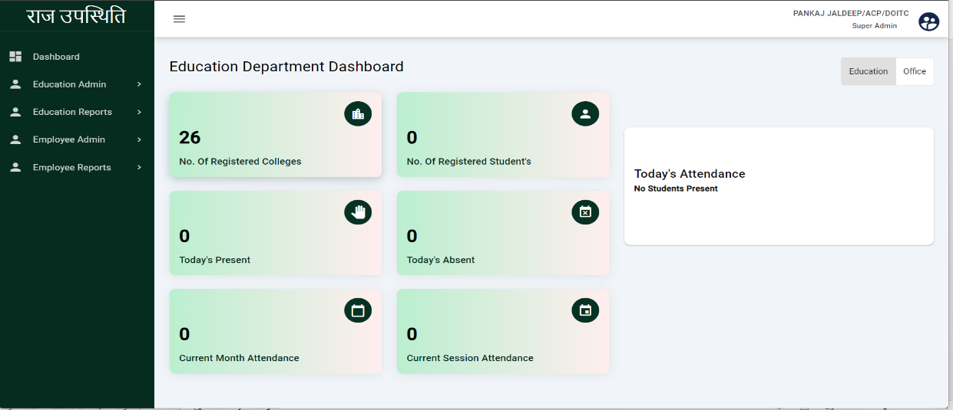**Dashboard:** Super admin Dashboard shows the No. of registered colleges, No. of registered students, Current month attendance, Current Session Attendance, etc. Employee Dashboard shows data related to employee attendance.

## Department Admin Registration

On this page, the Super admin can view the registered department admins. The super admin can register the department admin from here. Super admin can also enable and disable the department admin user.

Click here to register the department admin

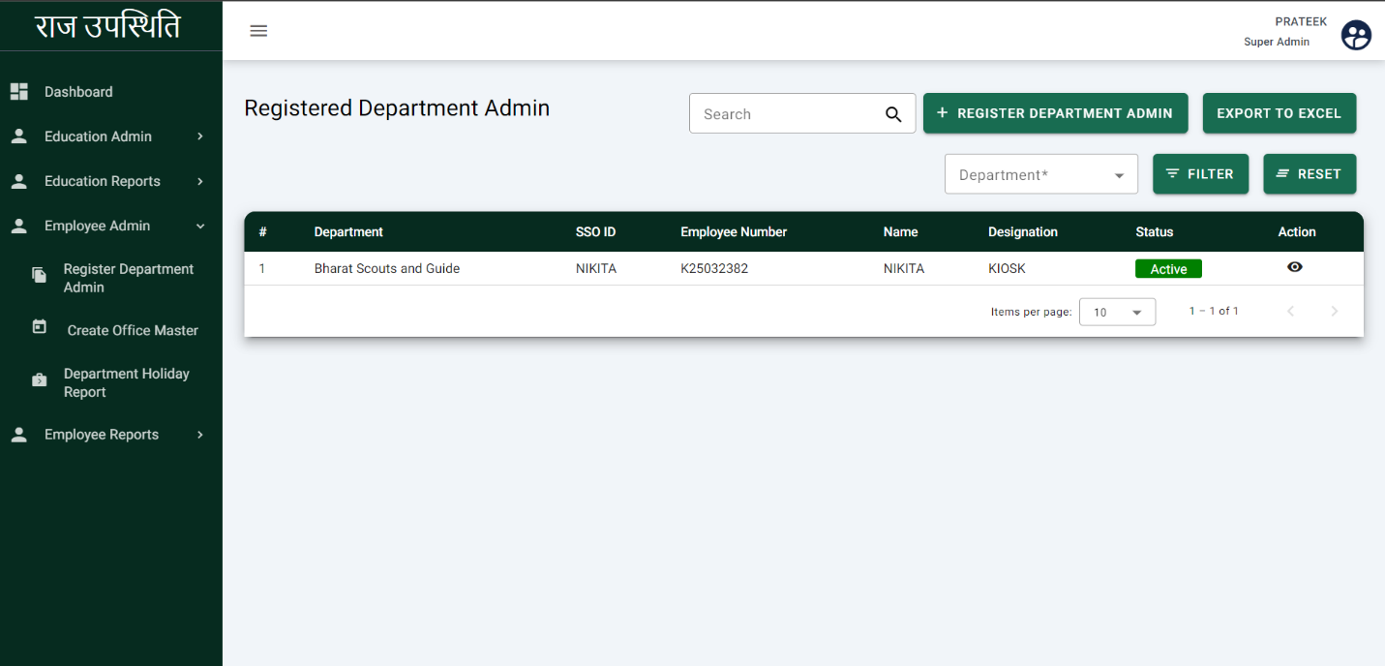

Click here to active and in active the user

* On this page, the already registered department admin will show.
* Super admin will click on the Register department admin and the following screen will show.

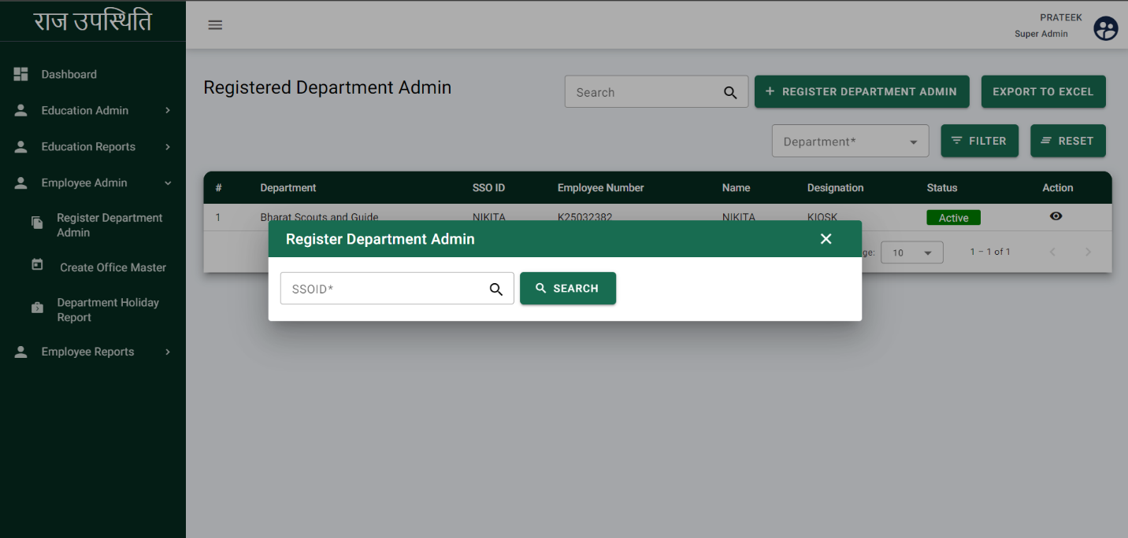

* Enter the SSO ID of the user, user details will be fetched from the backend.
* After clicking on search, the following page will be displayed

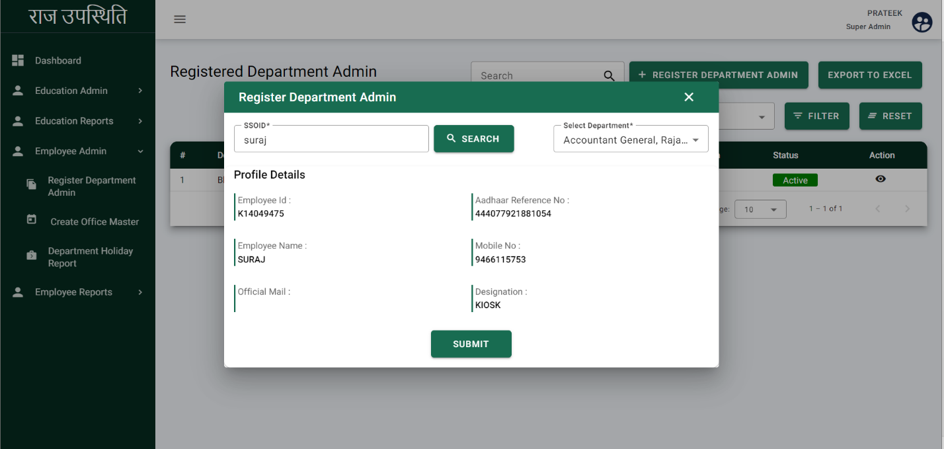

* Super admin will select the department from the dropdown.
* Click on the ‘SUBMIT’ and following page will be displayed.

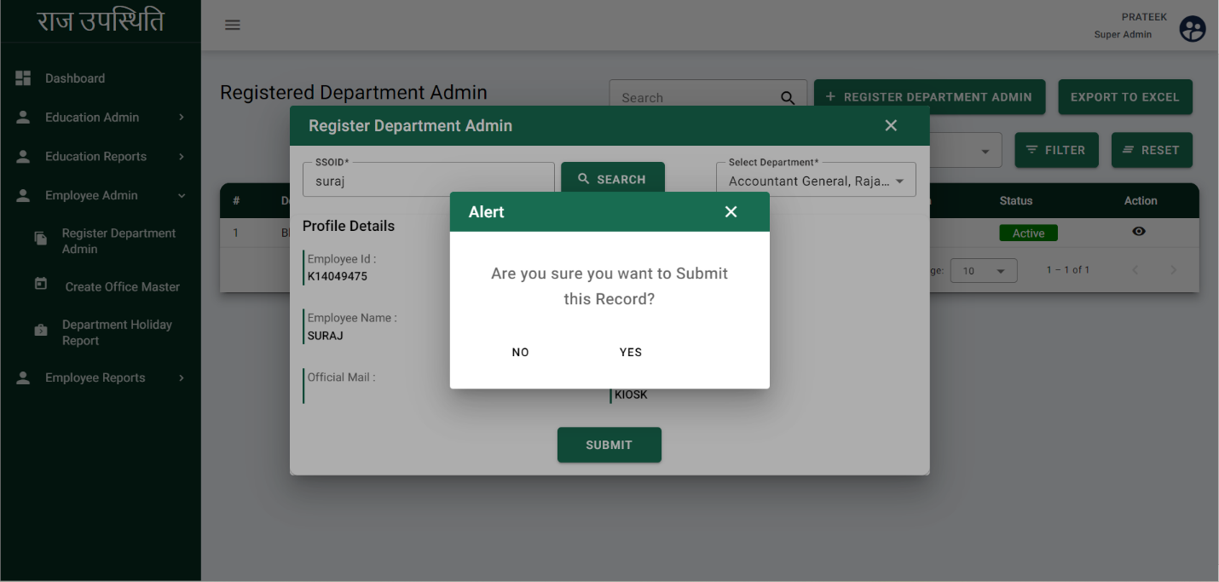

* After clicking on the submit button, an alert pop-up will be displayed.
* Click on the YES and the department admin will be registered successfully.

## Update Department Admin Status

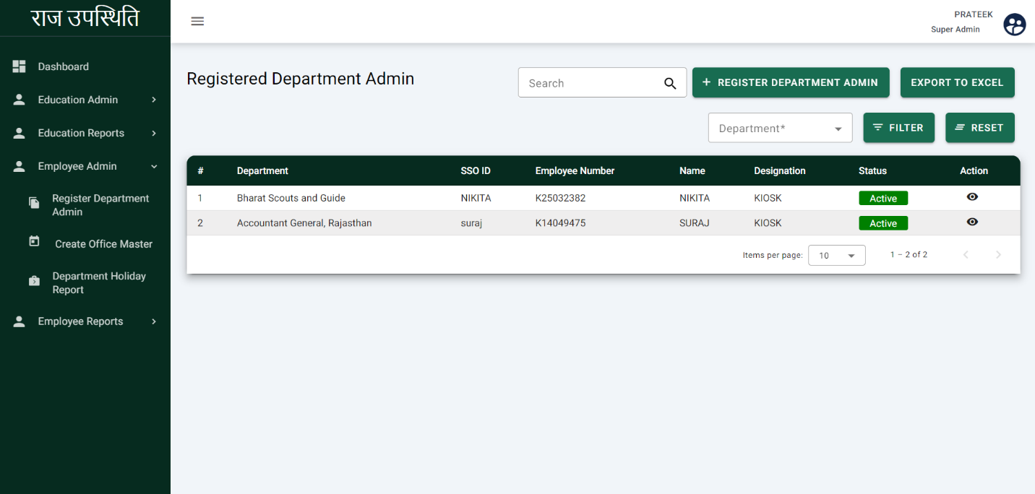Super admin will be able to update the department admin status i.e. Active and In-active.

Click here to Active and In-active department admin

* 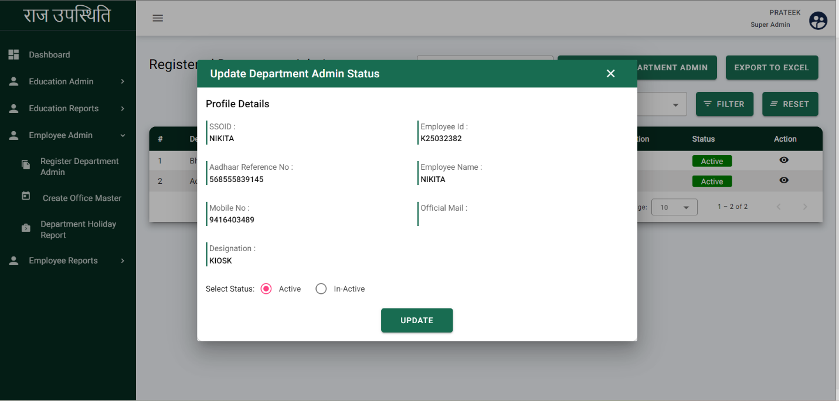After clicking on the action button following page will be displayed.
* Select the status active or In-active.
* Click on the update and status will be updated successfully

## Create Office Master

* Super admin will be able to view the already created office master and able to create new master.
* 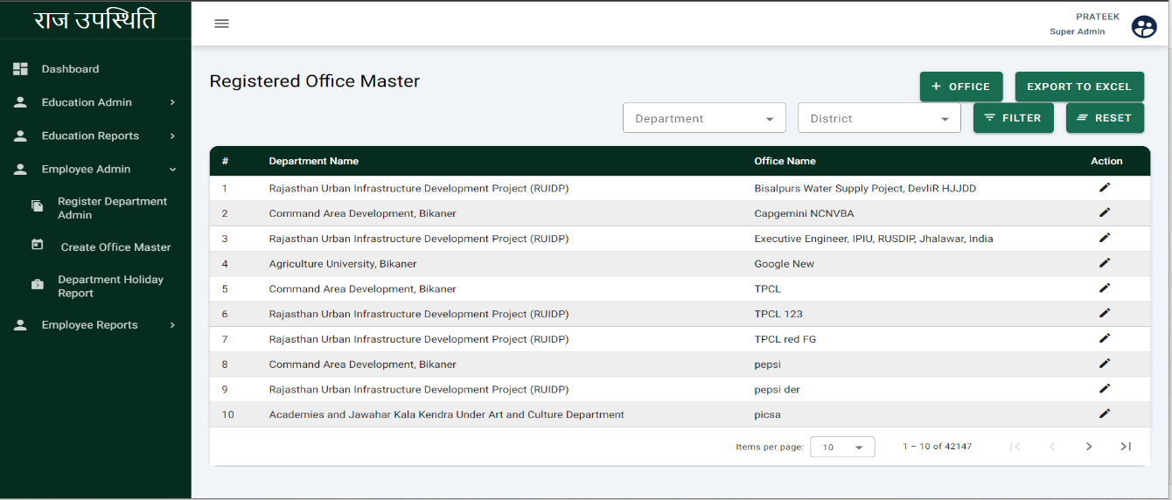Click on the Create office master and following page will be displayed

Click here to create the office master

* 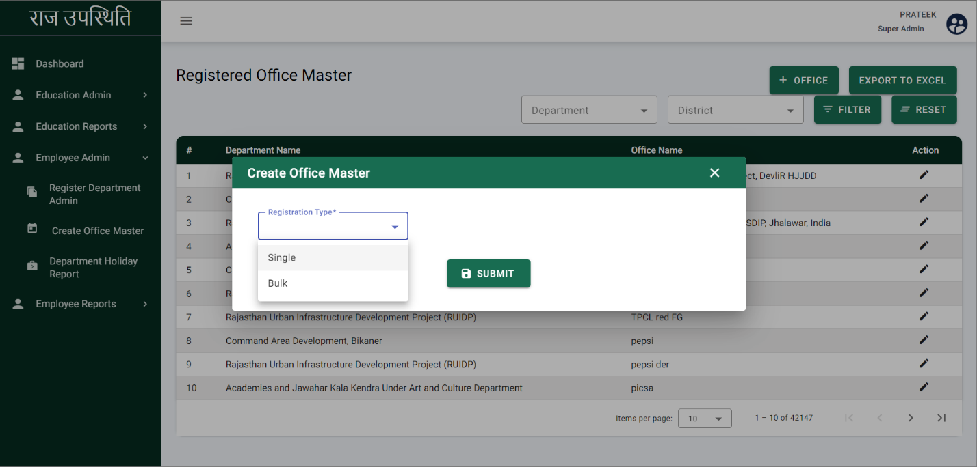To create the office master, click on the Office and following page will be displayed
* Choose Registration type i.e. single or bulk from the drop-down.
* Choose single from the dropdown
* Click on the ‘**SUBMIT’** and the following page will be displayed.

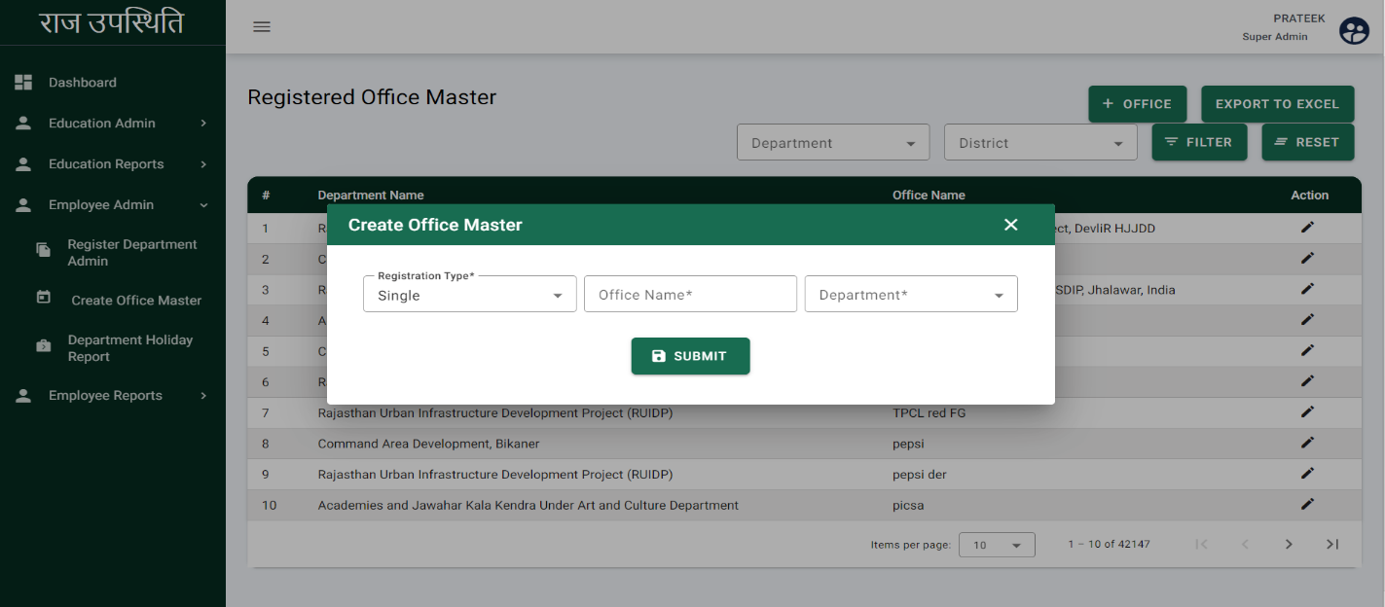

* Enter the Office name.
* Select the department from the dropdown.
* Click on the Submit button and following page will be displayed.

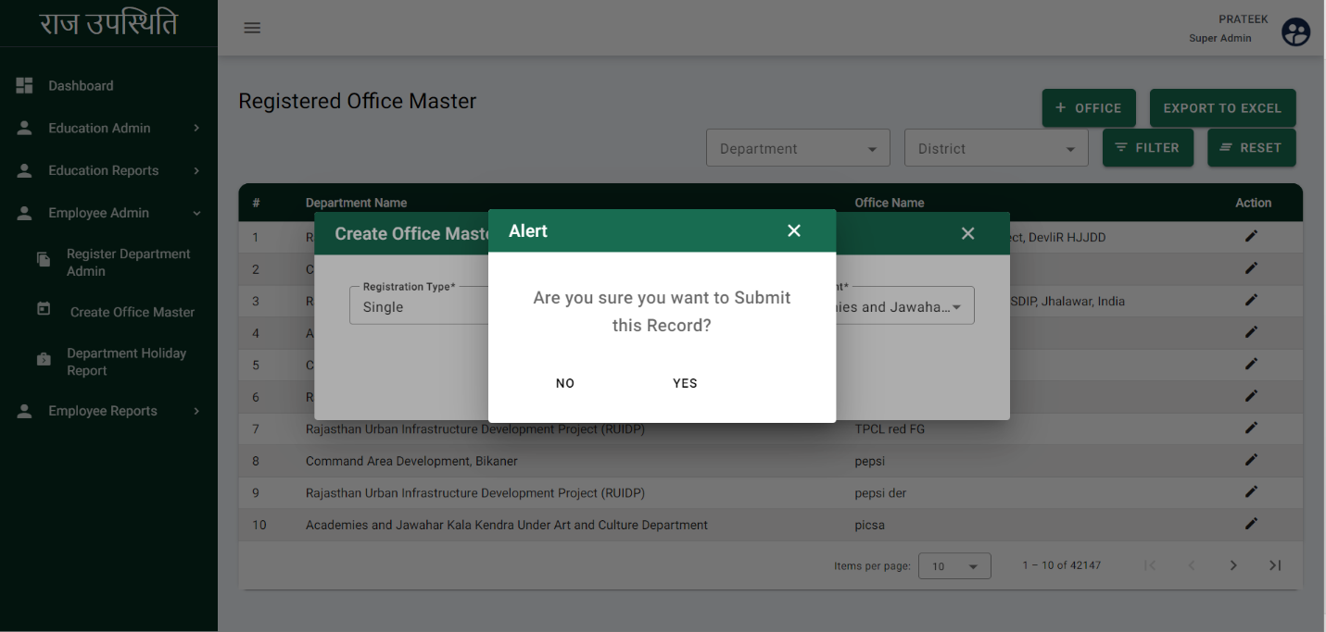

* After clicking on Submit alert pop-up will be displayed.
* Click on the YES and office master will be created successfully.
* 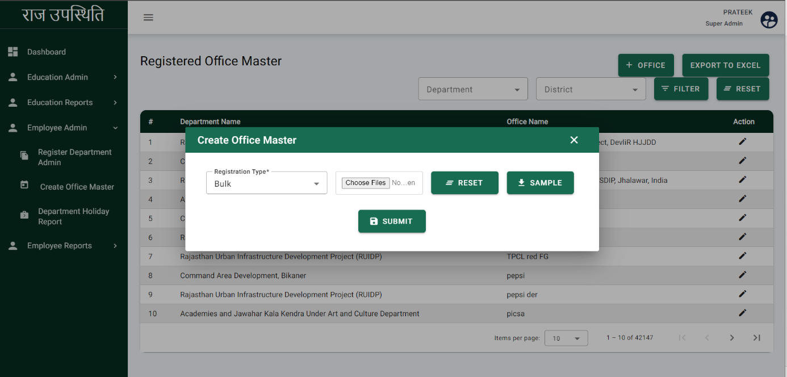If super admin selects the registration type BULK, following page will be displayed.
* Super admin can download the sample file.
* Choose the file from the device.
* Click on the Submit and office master will be created successfully.
* **Update Office Master**

Super admin will be able to update the office master details i.e. office name and department.

* Click on the Action button and the following page will be displayed

Click here to update the office master

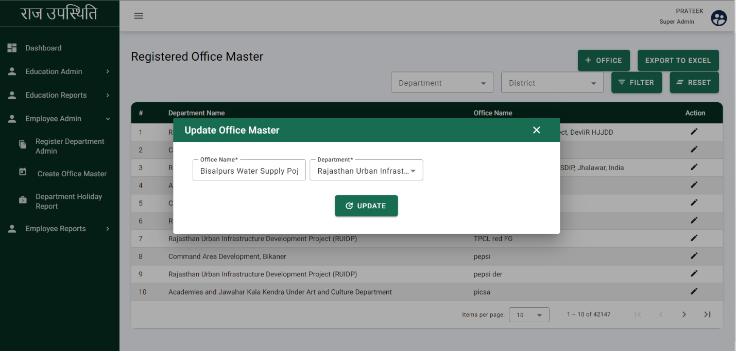

* Update Office name and Department.
* Click on the update and office master details will be updated.

## Holiday Creation

Super admin will be able to view already created holidays and add new holidays.

* 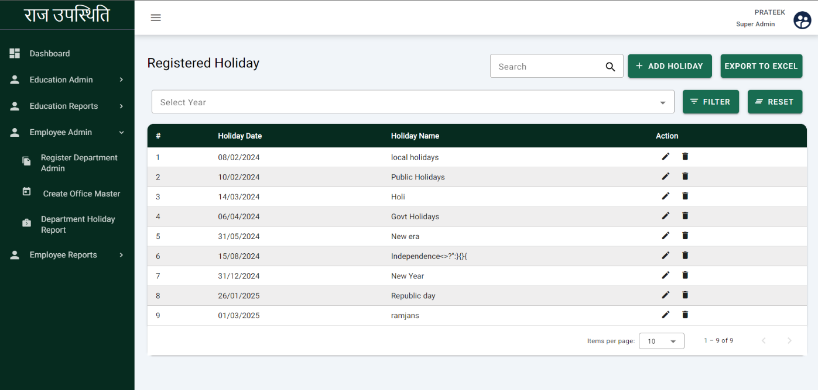From the navigation bar, click on the department holiday report and the following screen will be displayed.
* 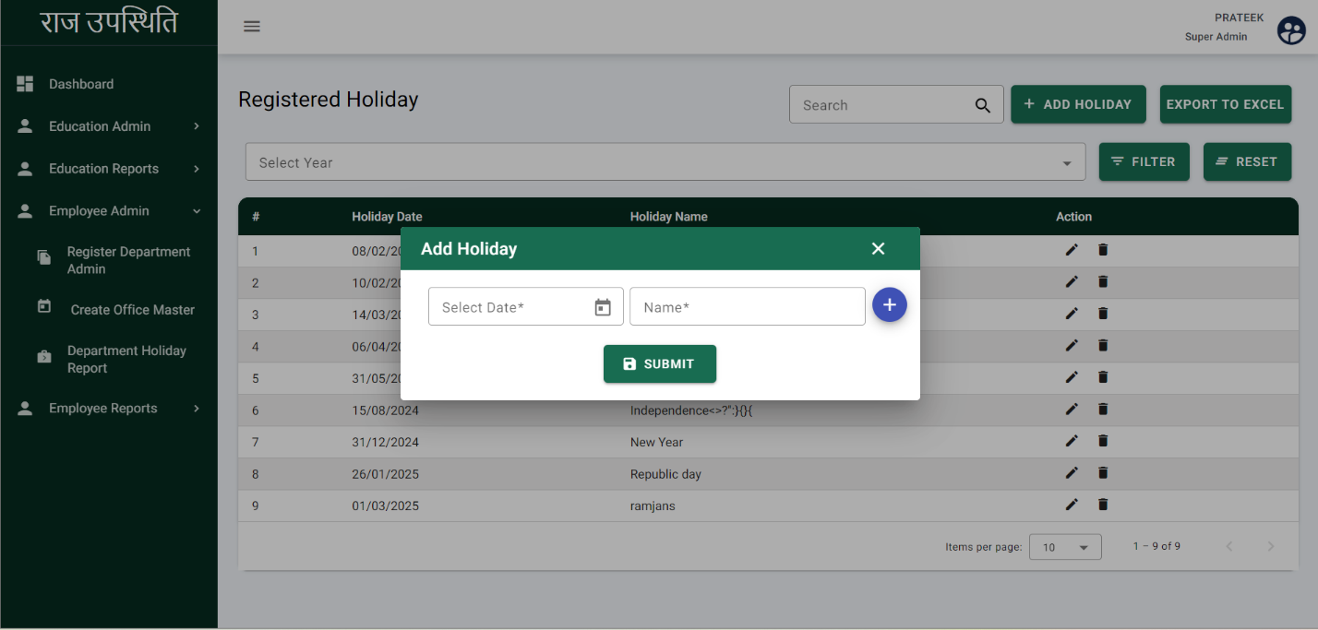To Add the holiday, click on the Add holiday and the following page will be displayed.
* Select the holiday date from the calendar.
* Enter the holiday name
* 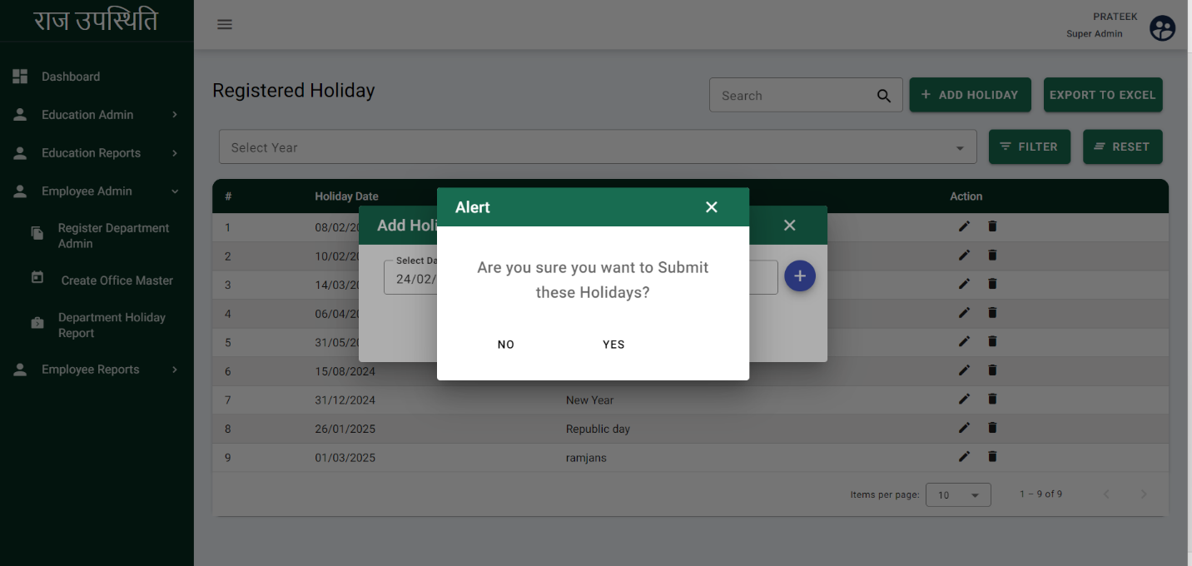Click on the Submit button and following page will be displayed.
* After clicking on Submit, an alert pop-up will be displayed.
* Click on Yes and the holiday will be added successfully.
* **Update Holiday**

Super admin will be able to update the holiday details i.e. holiday name and date.

Click here to update the holiday

* 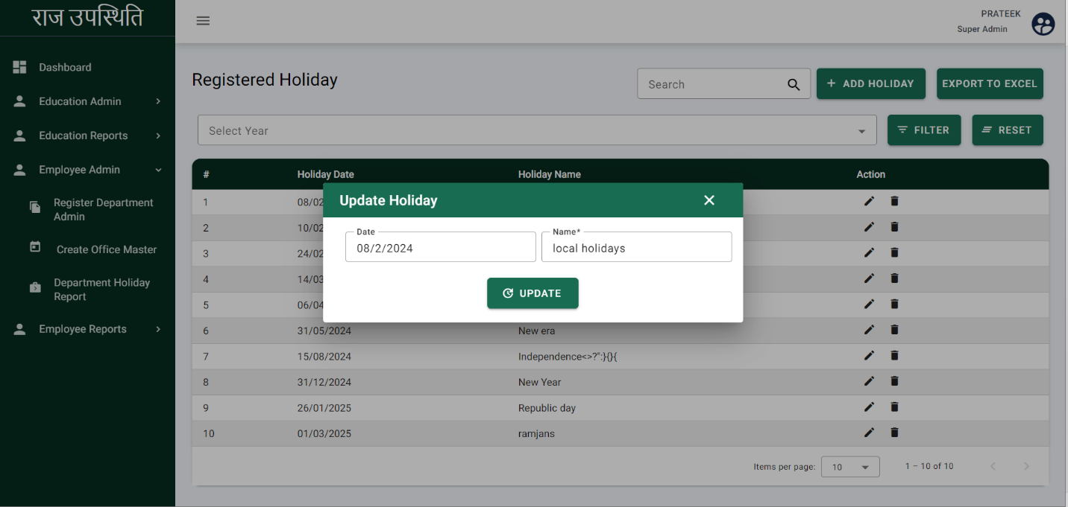After clicking on the Action button, the following page will be displayed.
* Update the Date and name of the holiday.
* Click on the Update and holiday will be updated successfully.

# Department Admin

Department admin will be in the the Raj-Upasthiti application who will be responsible to manage the employee admin.

* 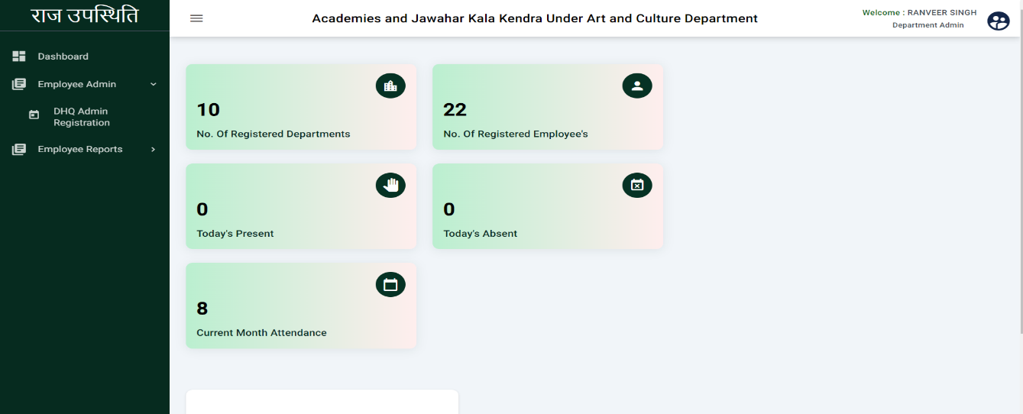**Dashboard:** The department admin dashboard shows the no. of registered departments, no. of registered employee, today’s present, today’s absent, current month attendance.

## DHQ Admin Registration

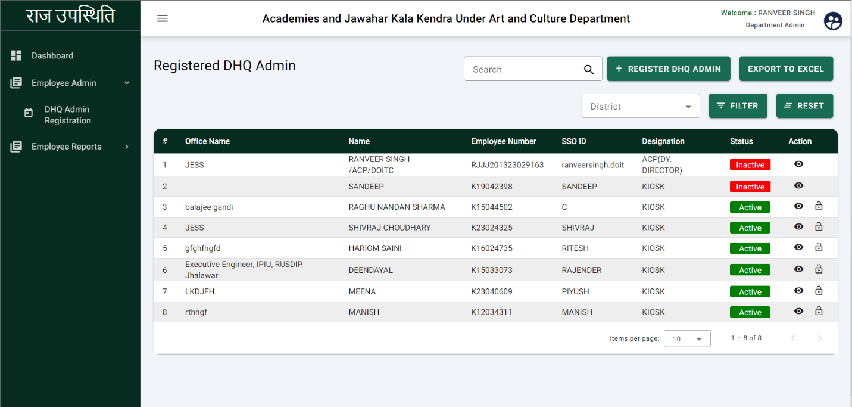On this page, the department admin can view the registered DHQ admins. The department admin can register the DHQ admin from here. Department admin can also enable and disable the DHQ admin user

* On this page already registered DHQ admin will show.
* 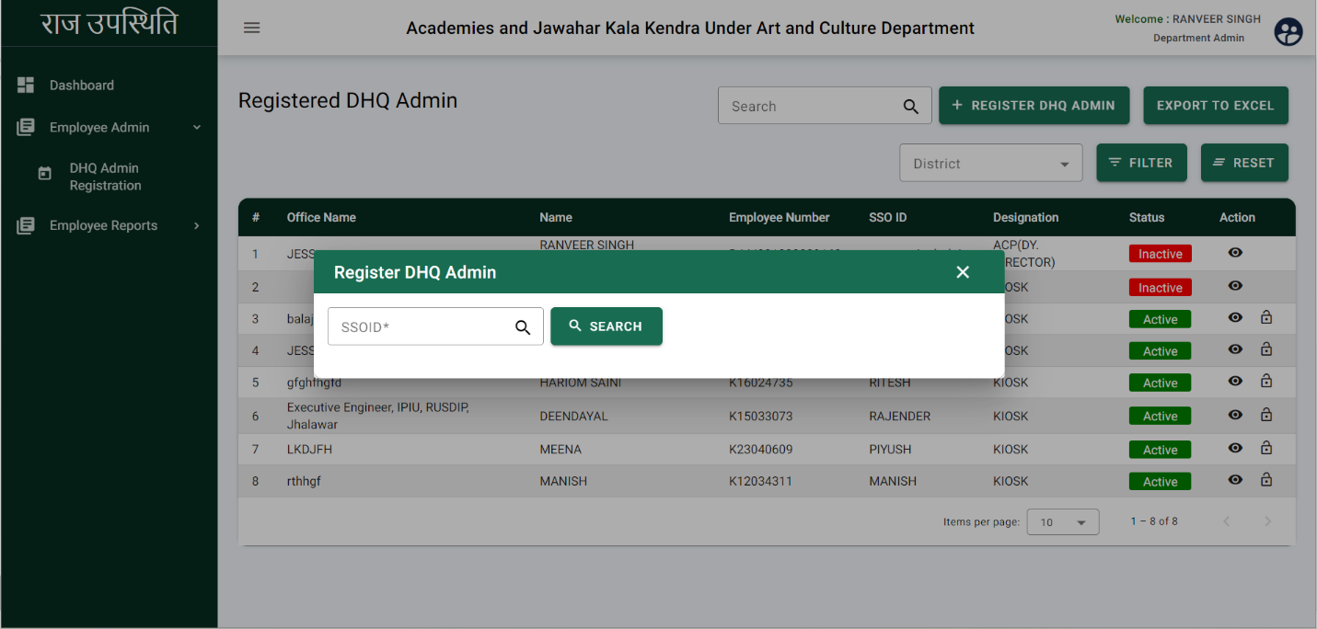To register the DHQ admin, click on the ‘**REGISTER DHQ ADMIN**’ and the following screen will be displayed
* Enter the SSO ID.
* 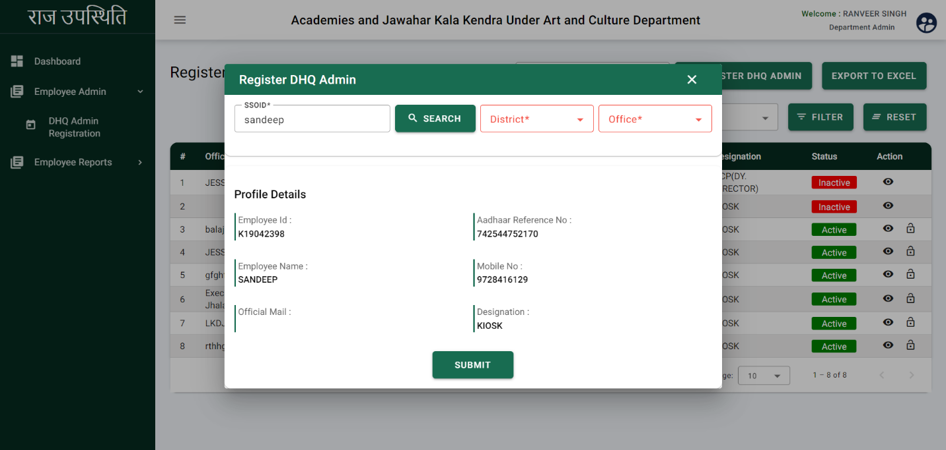Click on the search, user details will be fetched from the backed as below image.
* Select the district from the drop down.
* Select the Office from the dropdown.
* 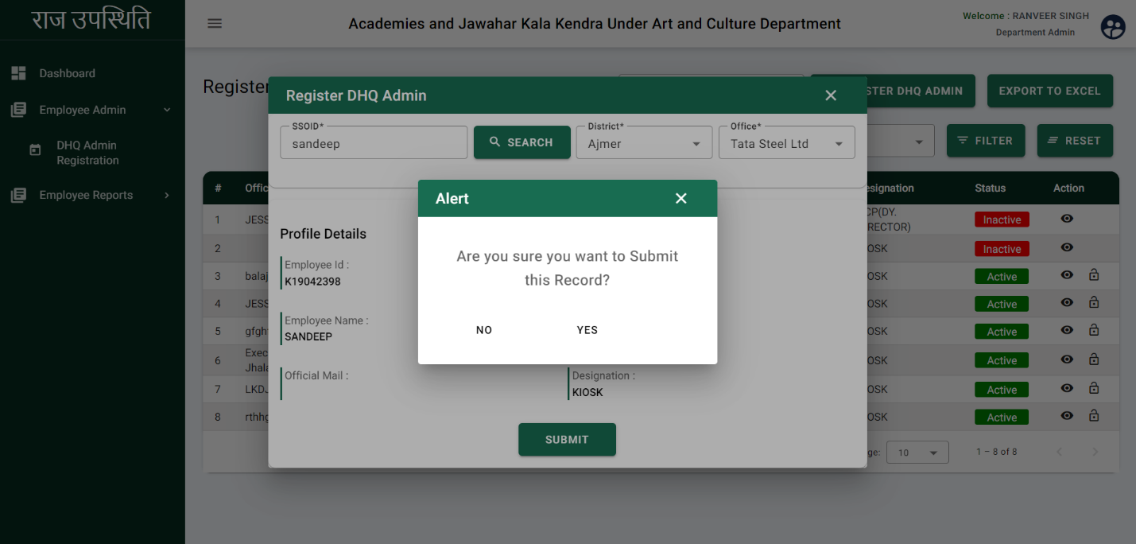Click on the submit button and following page will be displayed.
* After clicking on the submit alert pop-up will be displayed.
* Click on YES and DHQ admin will be registered successfully.
* **Update DHQ Admin Status**

Department admin will be able to update the DHQ admin status i.e. Active or In-active.



* 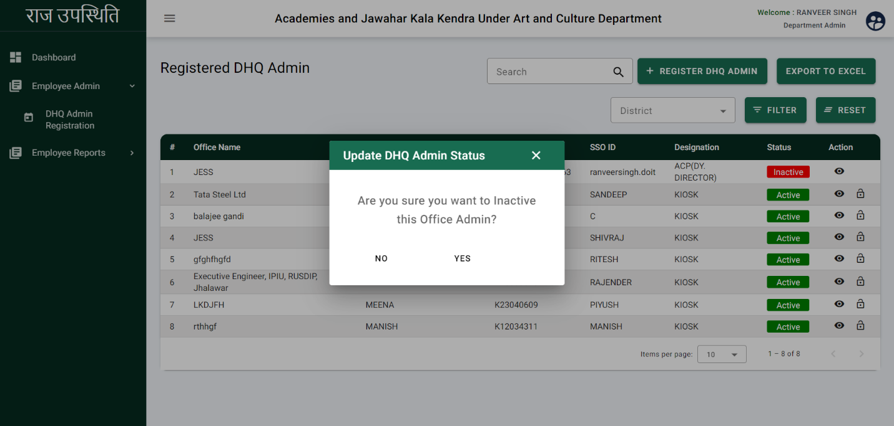To update the status, click on the Action button and following page will be displayed.
* After clicking on the action button update pop-up will be displayed.
* Click on the YES and status will be updated successfully.

## Employee Reports

Department admin will be able to view the various reports of the employee such as Office admin details, Office details, Employee details, Employee Attendance details, and Department holiday details.

* **Office Admin details**

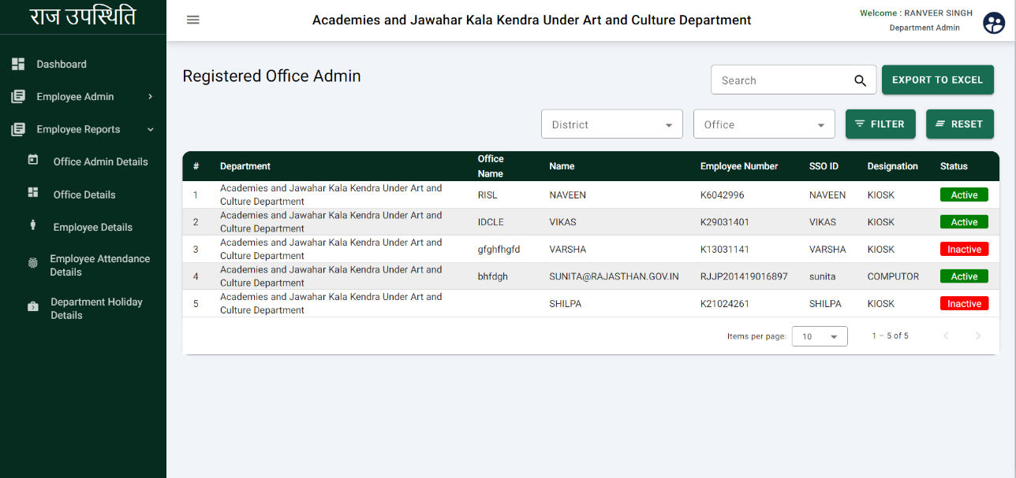In the office admin details, department admin will be able to view the list of registered office admin including their department, office name, Name, employee number, SSO ID, designation, and status.

* **Office details**

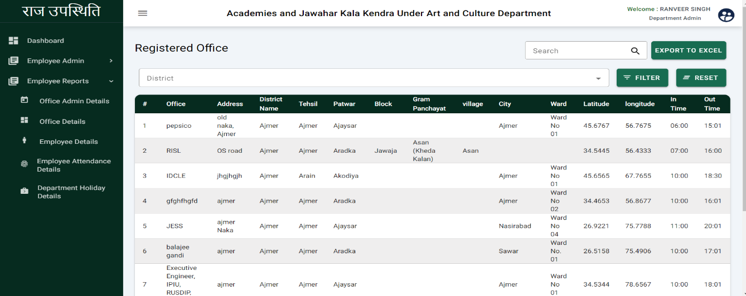In the office details, department admin will be able to view the list of registered office including their office name, Address, District Name, Tehsil, Patwar, Block, Gram Panchayat, Village, City, Ward, Latitude, Longitude, In time and Out time.

* **Employee Details**

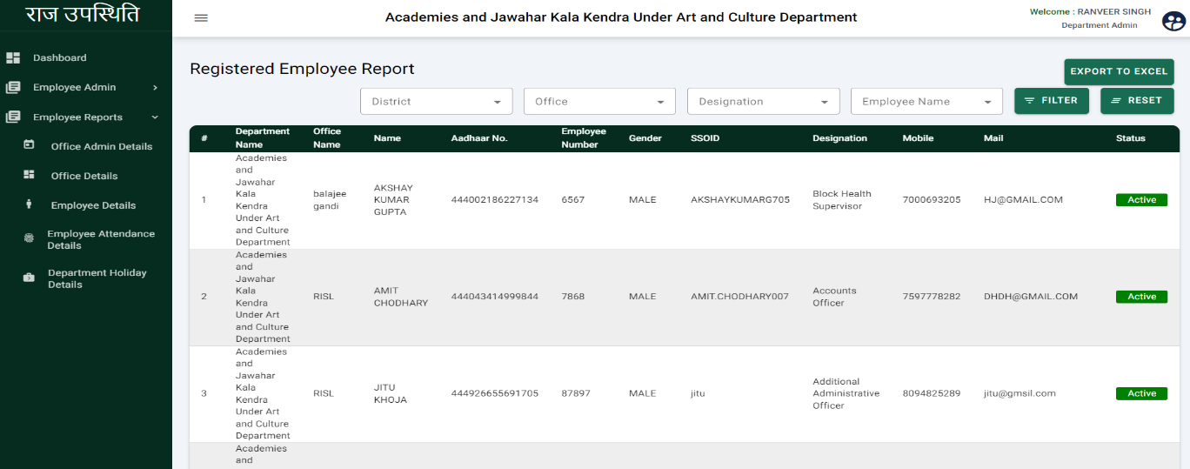In the employee details, department admin will be able to view the list of registered employees including their department name, Office Name, Name, Aadhaar No., Employee number, Gender, SSO ID, Designation, Mobile Number, Email ID, and Status.

* **Employee Attendance Details**

In employee attendance details, the department admin will be able to view the list of employee attendance including office name, designation name, Date range, total employee, total present, and total absent.

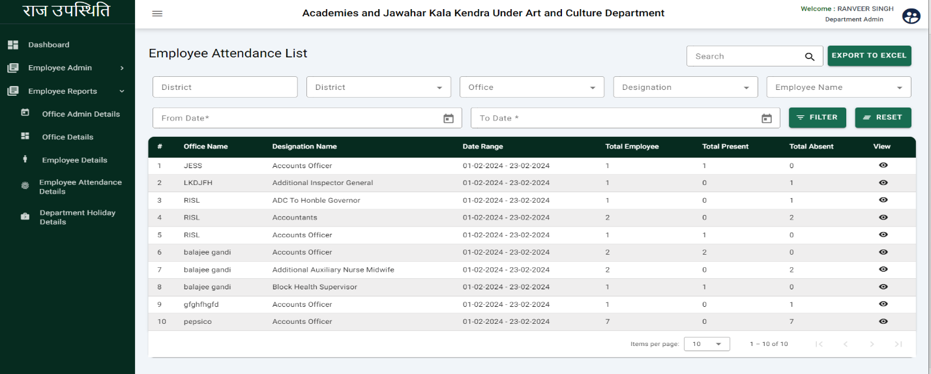

Click here to view the present of employees

* After click on the view button following page will be displayed.

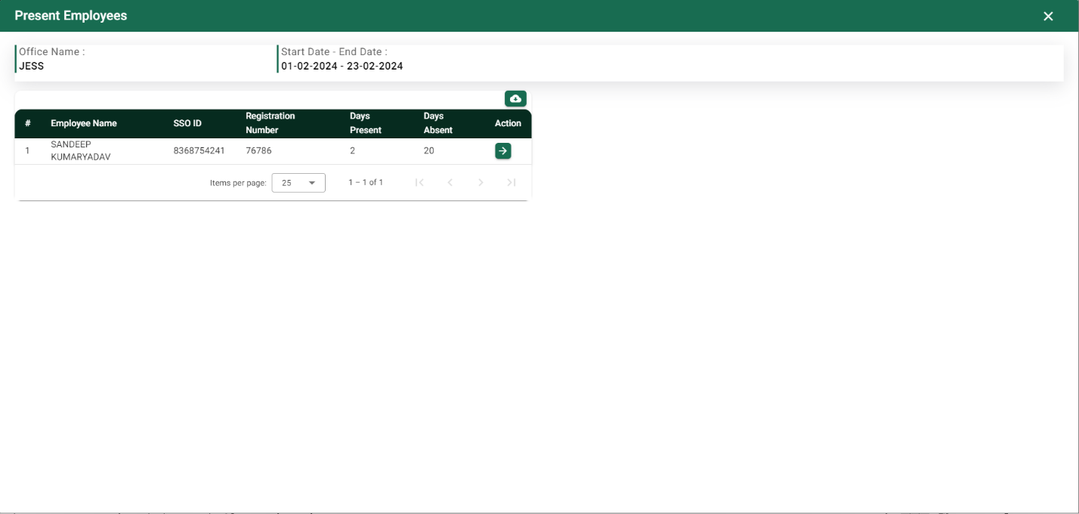

* **Department Holiday details**

In this department holiday details, department admin will be able to view the list of registered holidays including holiday dates and holiday names.

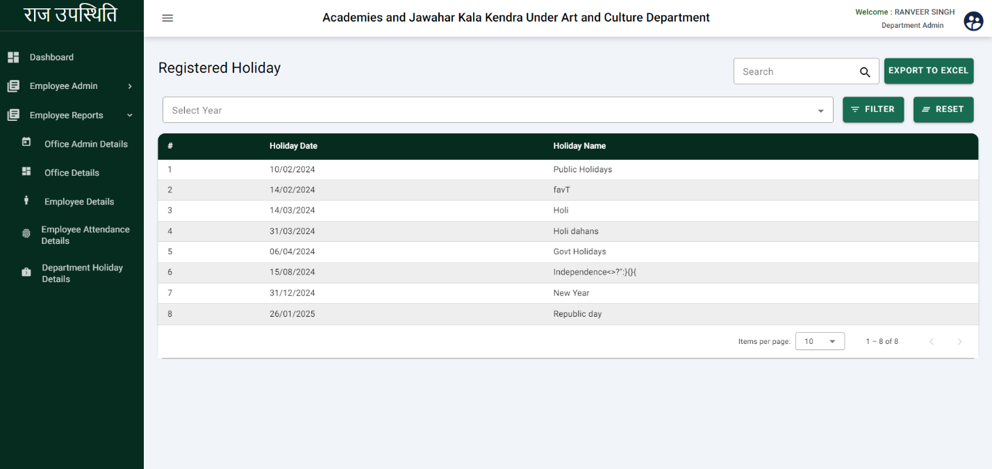

# Office Admin

Office admin will be responsible for managing the office, shift time, and reports of the employee. Office admin can register only one office.

* **Dashboard:** The office admin dashboard shows the No. of the registered employee, today’s present, today’s absent, current month's attendance and today’s attendance.

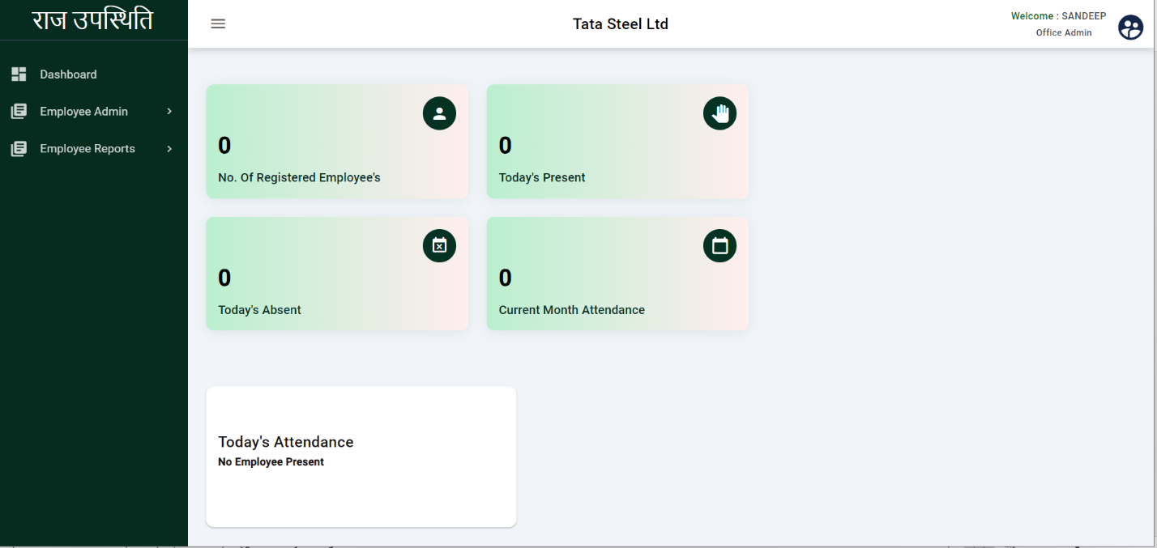

## Office Registration

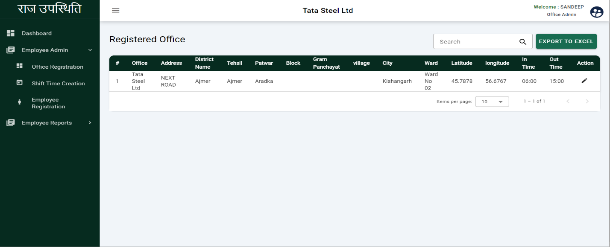On this page office admin will be able to view the list of registered office including office name, Address district name,Tehsil, Patwar, Block, Gram Panchayat, Village, City, Ward, Latitude, Longitude, In time, and Out time.

**The End**